APPENDIX J: SUGGESTIONS FOR CHAIRING AOS/RIBBON JUDGING AT SHOWS
Ribbon Judging (Joyce Medcalf) (A guide for associates)
- Read show schedule to learn about any ‘different’ rules/special trophies the show has. For example, can a plant be registered in more than one class? How does the show define a miniature? Does it give judge and/or give trophies to ‘no-name’ plants?
- Make up ribbon and AOS teams ahead of time when show chair sends you names of judges, lay judges and clerks.
- Type a summary sheet of teams, team members and class assignments for each team along with what, if any, trophies each team will award. If the registration finishes the day or night before, this may be done at that time. Give a copy of this sheet to each team or mount a large poster with this information on it for all to see. The show will need this information to be able to sort the entry names of plants or displays for each class into the appropriate groups for each team.
- Show morning, hand out show trophy ballots to accredited/associate judges and read usual preamble of rules and team assignments, noting special trophies for that show.
- Circulate the attendance sheet for all AOS judges and observers to sign.
- Calculate show trophy winner.
- Check Handbook on Judging as needed.
- Introduce yourself and give instructions to judges, lay judges and clerks for ribbon judging.
- Have a computer available so that teams can check names or parentage if there is any confusion over what class a plant should be in. Encourage judges to use a cell phone to check species names on the World Checklist of Selected Plant Families.

AOS Judging
- Plants are ‘pulled’ for AOS judging after ribbon judging is finished. Make a list of nominations of plants that are too large to ‘pull’ and will need to be judged in situ.
- Have a SHEET for in-situ plants.
- Take a picture of the display, so you know the exact spot where the plant belongs in the display when it is returned (good suggestion by Dave Sorokowsky).
- Leave a ’Plant Pulled for AOS Judging’ note in place of plant.
- Write a note that goes with the plant with:
- Name of plant and location (display number---if these numbers are removed after ribbon judging, then ask the show committee for a copy of display names with their numbers).
- Later, transfer this info to ‘Plants Nominated for AOS Judging Form’.
- List the pulled and in-situ plants on the Plants Nominated for AOS Judging Form.
- As awards are granted, or passed, fill in this ‘Plants Nominated for AOS Judging Form’ (see sample from Toronto Judging Centre that includes space for assuring that a plant has been owned 12 months for cultural awards) for a record, with the award number and award, award type and points.
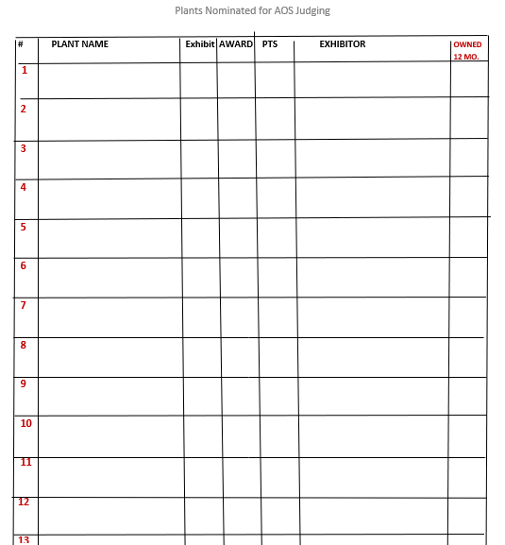TJC/Toronto Plants Nominated for AOS Judging Form

- If plant is awarded, write award number (e.g., 2019xxxx) on that ‘pulled’ sheet that was brought with the plant.
- That sheet can go to the photographer.
- There should be a list of award numbers in the show kit (forms, score sheets, award stickers, etc.) that the head of your judging center should provide.
- Check off numbers used.
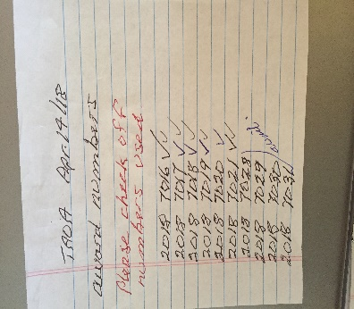 Sample list TJC/Toronto Award Numbers

Special Awards, Silver (85 or Gold certificate (90)
- A single score between 85 and 89 constitutes a nomination for a silver certificate requiring the formation of a special team. The same goes for a gold certificate; any single score of 90 or more constitutes a nomination.
- Form a team of at least 5 accredited judges.
- Show trophy must receive the highest score. If show trophy scores less than 85, no silver certificates are awarded to any display.
  - Educational Exhibit Certificate (80)7.3.4
  - Artistic Certificate (90)7.3.5
- Read the Handbook on Judging.

Provisional Awards and Photography
- A CHM/CBR and FIRST award to species MUST go to SITF Committee.
  - CHM - state reason granted
  - CBR - state country of origin
  - Use SITF form and/or detailed description, include plant info in description
  - Get permission from owner to remove a flower
  - Photos of dissected flower segments with ruler.
- If not the ‘Usual’ Photographer, he/she needs to sign ‘Photographer’s Permission Form’, which should be in the show kit.
- Give photographer ‘Award Photography Guidelines’. Make sure they understand them.
- Photographer takes picture of SITF form for his/her record
  - Photographer must include a copy of the SITF form with the pictures submitted to the appropriate person designated by the center.
- ALL awarded displays need to be photographed, with the ribbons removed.

Descriptions
- Input descriptions on computer fillable form.
- Record all info, clonal name etc. Fill in all the blank spaces.
- Write date and name of event in full.
- Fill in contact information of exhibitor.
- If exhibitor has received previous awards, the full name is enough. If unsure or think info it may have changed, then fill it out completely.
- Display awards need a clonal name, even if it is just the name of the exhibitor.
- Entire team reviews the description; team leader reads it followed by the head judge.
- Then print three copies.
- TEAM LEADER signs all three copies.
- Copy 1 with sticker goes to the EXHIBITOR.
- Copy 2 goes to the PHOTOGRAPHER.
- Copy 3 is kept as a record along with all remaining paperwork, INCLUDING SITF FORM, and is given to CENTER CHAIR at first opportunity.
- Add copy of AOS teams with all other paperwork (copy three). This is now added to the JC program.

Judging Summary Sheet/Attendance Sheet
Special awards, ST, SC, GC, etc. should be marked in the ‘other’ box.

